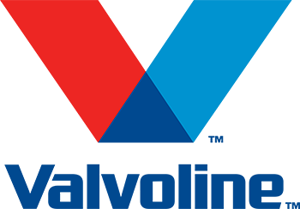
PRODUCT
INFORMATION

TURBO HYDRAULIC FLUID AW CZ 32, 46, 68
TURBO HYDRAULIC FLUID AW CZ is a range of mineral based hydraulic oils containing rust and corrosion inhibitors and also an anti-wear additive to ensure protection of equipment and pumps operating under severe service and high pressure conditions. They are recommended for use in industrial and mobile applications, operating under mild or severe conditions. Also excellent products for general industrial equipment, including machine tools, rotary air compressors, torque converters and enclosed gearboxes.

Features
• Excellent Hydrolytic Stability
• Outstanding thermal and oxidative stability
• Superior rust protection
• Minimal increases in air entrainment
• Very good demulsibility performance

Performance Level
Denison HF-0, HF-1, HF-2 (2005), DIN 51524 part I, II (2004),
Cincinnati Lamb P-68, P-69 and P-70, Eaton I-286-S3,
ASTM D6158, FZG A/8.3/90 load stage 10 pass,
Excellent wear protection in the Vickers 104C vane pump test

Viscosity | ISO VG 32 | ISO VG 46 | ISO VG 68
Specific Gravity (15/4℃) | 0.8659 | 0.8699 | 0.8739
Kinematic Viscosity (100℃, cSt) | 5.485 | 6.980 | 9.019
Kinematic Viscosity (40℃, cSt) | 32.35±1.6 | 46.46±2.3 | 69.36±3.4
Viscosity Index | 105 | 107 | 104
Flash Point (℃) | 212 | 216 | 220
Pour Point (℃) | -35.0 | -35.0 | -32.5
Copper Strip Corrosion | 1a | 1a | 1a
• Values shown are typical and may vary

